

Mathematics Department |  | 
Course: A1MAA
Topic Title: Test 2 – Calc Free
Student Name:_____________________________________ | Date: ____________
Special Instructions: Formula Sheet Allowed | Time Allowed:
 | Marks: / 27

Question 1. (2 marks)
Using the formula v = u + at, calculate v given: u =16, a =0.5 and t = 15

Question 2. (2, 2 : 4 marks)
If $x = 2$ , $y= -3$, and $z = -5$ , then find the values of:
a) $5x^{2}$ b) $\frac{x-y}{yz}$

Question 3. (1,1,1 : 3 marks)
If e_{mn} is the element situated in the m^{th} row and n^{th} column of matrix E determine
a) e₃₃ b) e₂₁ c) f₁₂

where matrices E and F are as given below.
E = 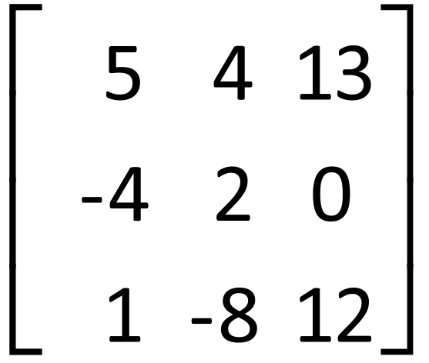 F = 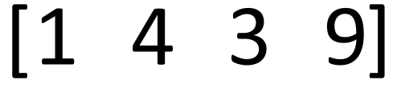

Question 4. (2,2,2,2,2,2:12 marks)
If A = 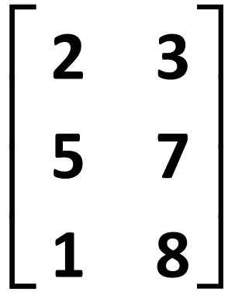 B = 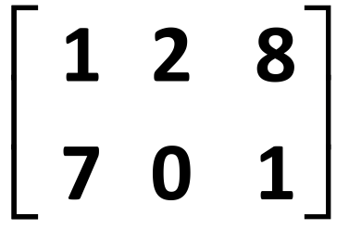 C = 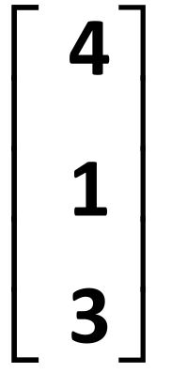 D = 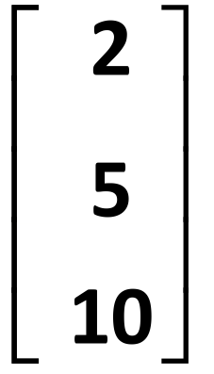 E = 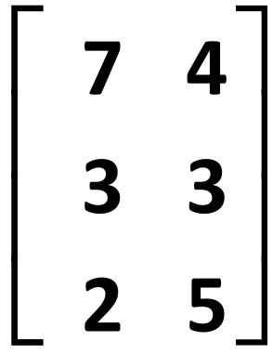

determine each of the following. If any cannot be determined state this clearly and explain why

a) E + A b) 3B

c) 2D - C d) BD

e) CE f) A²

Question 5. (1,3,2 : 6 marks)
Give matrices to fit the following descriptions.
a) A row matrix with 3 columns (using any values)

b) A square matrix A in which there are 2 rows and a_{mn} = m + n

c) Tickets to an exhibition are cheaper on weekdays than weekends. Adult tickets are $15 on
weekdays and $20 on weekends. Student tickets are $10 on weekdays and $12 on weekends.

